1. **Create Database schema and insert records**

Create assignment schema in Mysql and run below sql file



I have used below url in my application for mysql connectivity

**spring.datasource.url=jdbc:mysql://localhost:3306/assignment**

1. **Generate access_token**

Now open postman in chrome browser and type below url

User : admin Password: welcome

http://localhost:8080/oauth/token

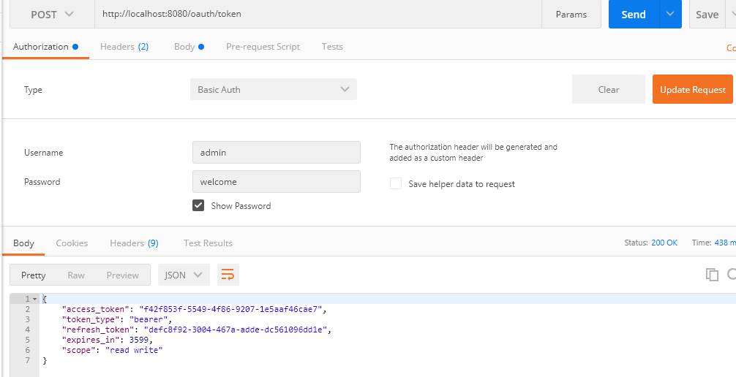

Without token

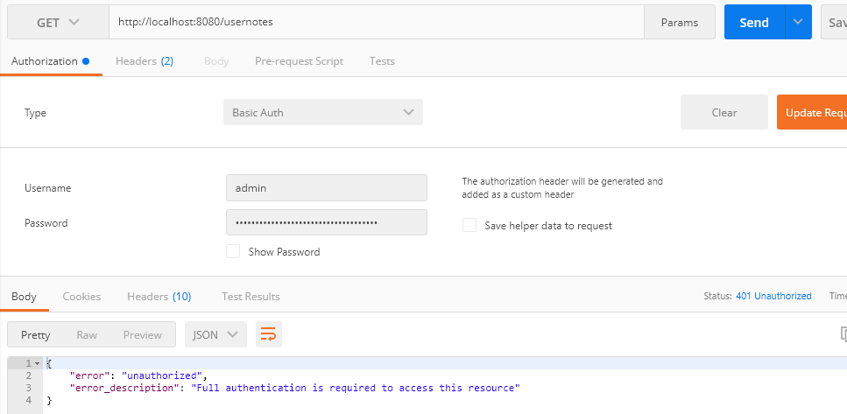

1. **Use access token to fetch user Notes**

Below service only fetch user created notes (Notes owned by user)

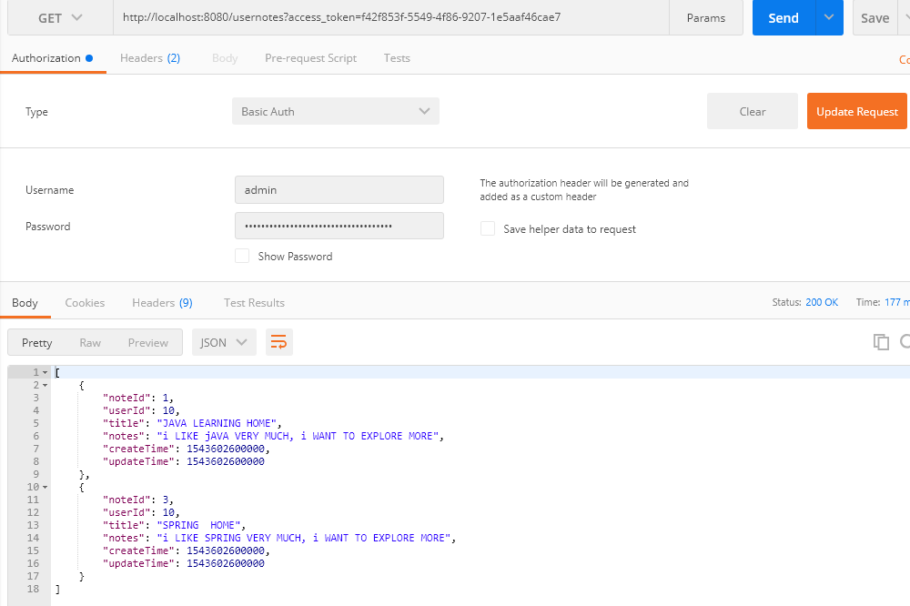

1. Create New User Note

URL : <http://localhost:8080/usernotes>

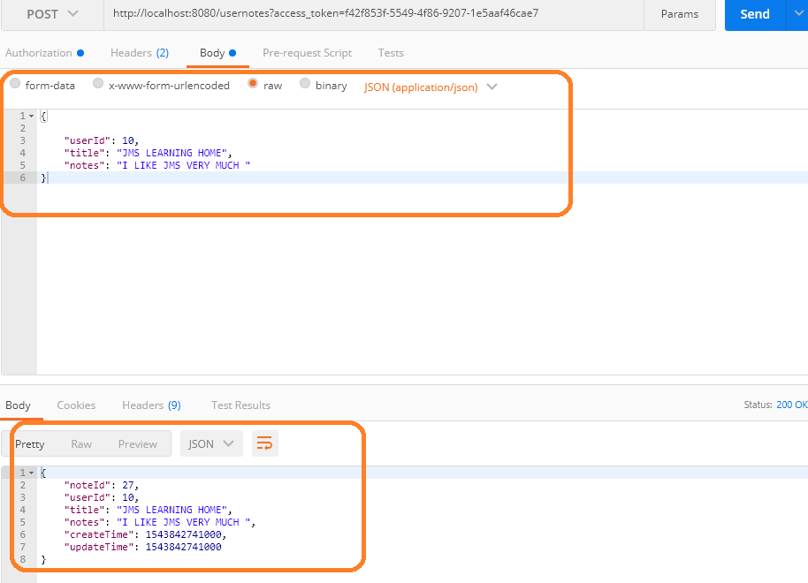

**5)Update existing User Note**

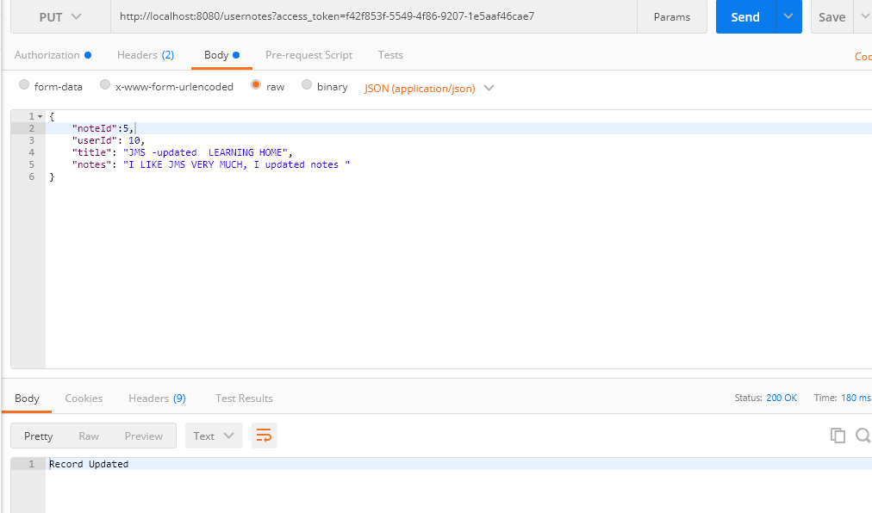

When User is trying to update, other user note

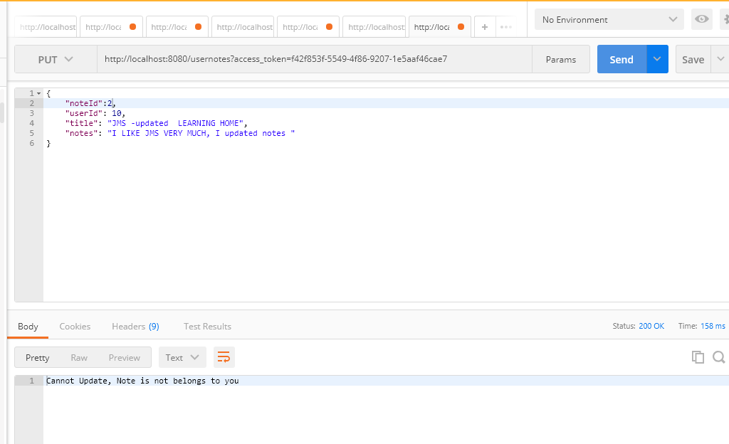

1. **Deleting user Note**

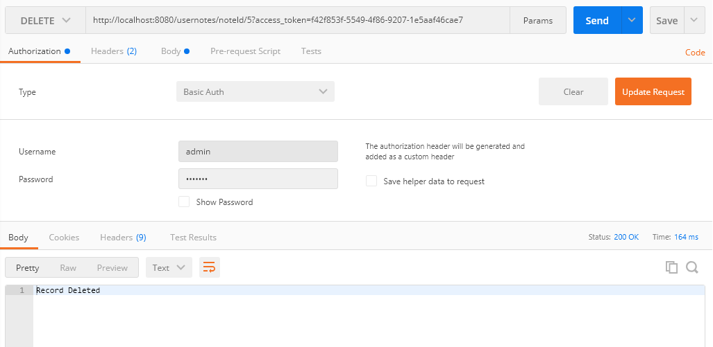

When deleting other user notes

